Beholder’s Almanac

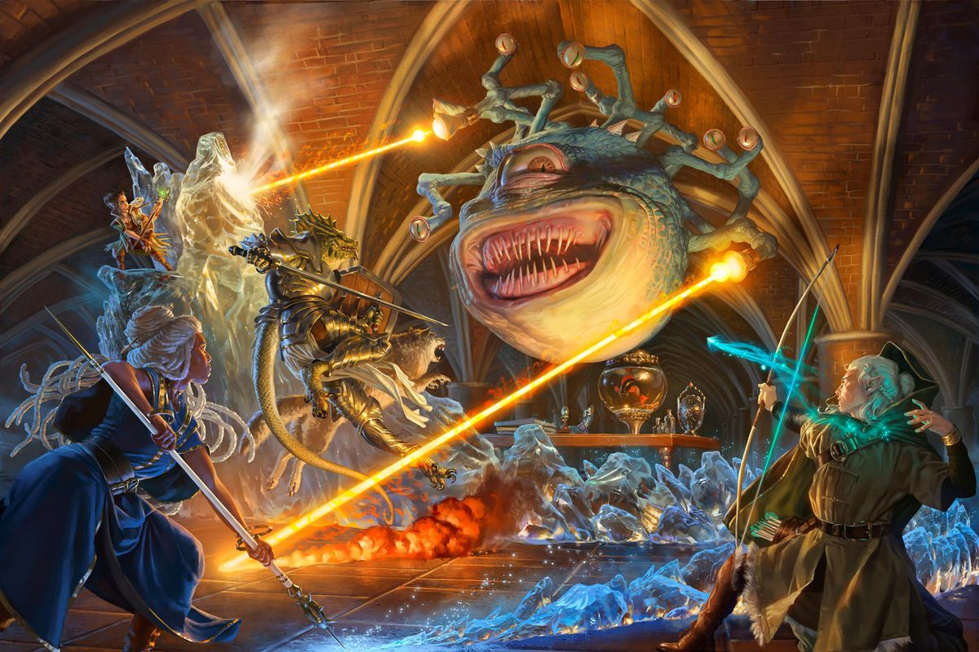

Source: <https://www.polygon.com/23023498/hasbro-buys-dnd-beyond-pdf-wotc-fandom>

Contents

1 OOAD Diagrams 3

1.1 Updated Use Case Diagram 3

1.2 Use Case Specifications 3

1.2.1 Use Case #1: 3

1.2.2 Use Case #2: 3

1.2.3 Use Case #3: 3

1.2.4 Use Case #4: 3

1.3 Class Diagram 3

1.4 Sequence Diagrams 3

1.5 State Machine Diagram 3

2 Project Level Summary Evaluation – Analysis and Design 4

3 Risk Assessment Matrix 4

4 Updated Project Plan 4

# OOAD Diagrams

# Updated Use Case Diagram

# 

# Use Case Specifications

## 1.2.1 Use Case #1: Character Sheet

|  |  |  |  |
| --- | --- | --- | --- |
| Use Case Name: **Character Sheet** | | ID: character_sheet | Importance Level: High |
| Primary Actor: General User | Use Case Type: Standard | | |
| Stakeholders and Interests: General User | | | |
| Brief Description: The user is brought to the character sheet page where they have the option to start a new character sheet, load an existing sheet or return to the main menu. | | | |
| Trigger: Button press from the main menu.  Type: Mouse left click or touch screen tap | | | |
| Relationships:  Association: Main Menu  Include: Return to main menu  Extend: Add new character, Load existing character  Generalization: Main Application Function | | | |
| Normal Flow of Events:   1. User clicks Character sheet from Main Menu. 2. User selects either new character, existing character, or main menu. 3. Functions proceeds depending on which option user chooses. | | | |
| Sub Flows:  S-1: Using mouse clicks   1. User hovers mouse cursor over preferred option and left clicks. 2. Depending on button chosen application proceeds to next operation.   S-2: Using touchscreen   1. User taps preferred option using either their hand or stylus. 2. Depending on button chosen application proceeds to next operation. | | | |
| Alternate/Exceptional Flows: none | | | |

## 1.2.2 Use Case #2:

|  |  |  |  |
| --- | --- | --- | --- |
| Use Case Name: **Dice Roller** | | ID: dice_roller | Importance Level: High |
| Primary Actor: General User | Use Case Type: Standard | | |
| Stakeholders and Interests: General User | | | |
| Brief Description: The user is brought to the dice roller page where they have the option to roll different dice depending on which dice face they choose. After selecting the dice, a display will populate with the results. | | | |
| Trigger: Button press from the main menu.  Type: Mouse left click or touch screen tap | | | |
| Relationships:  Association: Main Menu  Include: Return to main menu  Extend: Roll Dice, Display dice output  Generalization: Main Application Function | | | |
| Normal Flow of Events:   1. User clicks Dice Roller from Main Menu. 2. User selects a dice face, or main menu. 3. If dice face is selected a text output appears showing results of roll. 4. Functions proceeds depending on which option user chooses. | | | |
| Sub Flows:  S-1: Using mouse clicks   1. User hovers mouse cursor over preferred option and left clicks. 2. Depending on button chosen application proceeds to next operation.   S-2: Using touchscreen   1. User taps preferred option using either their hand or stylus. 2. Depending on button chosen application proceeds to next operation. | | | |
| Alternate/Exceptional Flows: none | | | |

## 1.2.3 Use Case #3:

|  |  |  |  |
| --- | --- | --- | --- |
| Use Case Name: **Music Player** | | ID: music_player | Importance Level: low |
| Primary Actor: General User | Use Case Type: Standard | | |
| Stakeholders and Interests: General User | | | |
| Brief Description: The user can turn on background music from the main menu by clicking the “ON” button. Upon leaving page, clicking “OFF” or the song playing completely the music player will end freeing up system resources. | | | |
| Trigger: Button press from the main menu.  Type: Mouse left click or touch screen tap | | | |
| Relationships:  Association: Main Menu  Include:  Extend: Turn Music On, Turn Music Off  Generalization: Main Menu Application Function | | | |
| Normal Flow of Events:   1. User clicks Character sheet from Main Menu. 2. User selects either new character, existing character, or main menu. 3. Functions proceeds depending on which option user chooses. | | | |
| Sub Flows:  S-1: Using mouse clicks   1. The user can turn on background music from the main menu by clicking the “ON” button. 2. Upon leaving page, clicking “OFF” or the song playing completely the music player will end freeing up system resources.   S-2: Using touchscreen   1. User taps preferred option using either their hand or stylus. 2. Depending on button chosen application proceeds to next operation. | | | |
| Alternate/Exceptional Flows: none | | | |

## 1.2.4 Use Case #4:

|  |  |  |  |
| --- | --- | --- | --- |
| Use Case Name: **Settings** | | ID: settings | Importance Level: medium |
| Primary Actor: General User | Use Case Type: Standard | | |
| Stakeholders and Interests: General User | | | |
| Brief Description: The user is brought to the settings page where they have the option to submit a bug report and view application data. | | | |
| Trigger: Button press from the main menu.  Type: Mouse left click or touch screen tap | | | |
| Relationships:  Association: Main Menu  Include:  Extend:  Generalization: Main Application Function | | | |
| Normal Flow of Events:   1. User clicks Settings from Main Menu. 2. User can send bug report to administrator to review. 3. User can review current build number for application and general application information. | | | |
| Sub Flows:  S-1: Using mouse clicks   1. User hovers mouse cursor over preferred option and left clicks. 2. Depending on button chosen application proceeds to next operation.   S-2: Using touchscreen   1. User taps preferred option using either their hand or stylus. 2. Depending on button chosen application proceeds to next operation. | | | |
| Alternate/Exceptional Flows: none | | | |
|  | | | |

# Class Diagram



# Sequence Diagrams





# State Machine Diagram



# Project Level Summary Evaluation – Analysis and Design

* What would you do better or differently?
  + Taking more time in initial planning would have helped outline the project scope and resources needed.
  + Some variables have similar names which can cause confusion if documentation isn’t done properly.
* Do they have a good understanding of key risks for their projects and how to mitigate risk (external and internal)?
  + Yes risks have been documented and are minimal due to likely non-public release.
* What additional risks would you consider for the project (minimum of three)?
  + Time risk may be present as application is currently being developed on an accelerated schedule.
  + Market risk exists if application goes public.
  + Performance risks may be applicable to users with outdated firmware.

# Risk Assessment Matrix

Risk scale: 1 = low, 2 = fair, 3 = medium, 4 = probable, 5 = high

|  |  |  |  |  |
| --- | --- | --- | --- | --- |
| **Risks** | Likelihood | Preventive Measure | Response | Impact |
| Hardware Failure | 2 | * Test on multiple platforms to ensure wide functionality. | * Utilize bug report within settings | * Schedule * Budget |
| Cost Risk | 3 | * Establish budget based off initial requirement scope * Update budget routinely throughout development | * Find other resources of money to help support your project | * Budget |
| Appropriate API | 2 | * API 28 has been chosen for wide coverage 98.6% and functionality. * Always look for cost, support, and reviews | * Unsure marketing targets devices with at least API 28. | * Requirements * Schedule * Budget |
| Time Constraints | 5 | * Make a schedule that allows for periodic meetings to update advancement | * Alternating paperwork and technical work each week * Set weekly goal to motivate and challenge us | * Schedule |
| Technology Risks | 3 | * Test on multiple platforms to ensure wide functionality. | * List API requirements on Play store | * Launch |
| Marketing Risks | 3 | * Use surveys, questionnaires, and reviews to get customers opinion of product | * Rework product by changing requirements | * Requirements |

# Updated Project Plan

